

**DEPT. of Computer Science Engineering**

**SRM IST, Kattankulathur – 603 203**

**Sub Code & Name: 18CSS201J - ANALOG AND DIGITAL ELECTRONICS**

|  |  |
| --- | --- |
| **Experiment No** | **07** |
| **Title of Experiment** | **Design and implementation of magnitude comparator** |
| **Name of the candidate** |  |
| **Register Number** |  |
| **Date of Experiment** |  |

**Mark Split Up**

|  |  |  |  |
| --- | --- | --- | --- |
| **S.No** | **Description** | **Maximum Mark** | **Mark Obtained** |
| 1 | Oral Viva | 5 |  |
| 2 | Circuit Connection and Execution | 10 |  |
| 3 | Verification of truth table | 5 |  |
| **Total** | | **20** |  |

**Staff Signature with date**

**7. a. Design and implementation of Magnitude Comparator Combinational circuits using simulation package**

**Aim**

To Design a magnitude comparator using Multisim software and to verify its truth table.

**Apparatus / Software Required:**

MULTISIM SOFTWARE

### Theory:

A magnitude digital comparator is a combinational circuit that compares two digital or binary numbers in order to find out whether one binary number is equal, less than or greater than the other binary number. We logically design a circuit for which we will have two inputs one for A and other for B and have three output terminals, one for A > B condition, one for A = B condition and one for A < B condition.

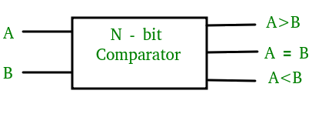

Figure-1: Block Diagram of Comparator

### 2-Bit Magnitude Comparator:

A comparator used to compare two binary numbers each of two bits is called a 2-bit magnitude comparator. It consists of four inputs and three outputs to generate less than, equal to and greater than between two binary numbers.

**Truth Table:**

The truth table for a 2-bit comparator is given below:

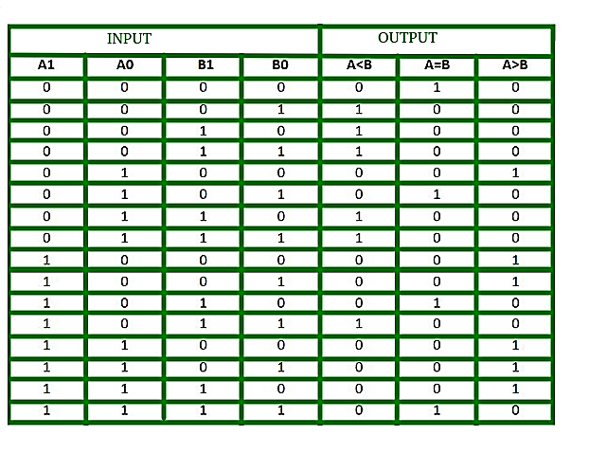  
Figure-2: Truth Table of 2-Bit Comparator

The logical expressions for each output can be expressed as follows:  
A > B : A1B1’ + A0B1’B0’ + A1A0B0’  
A = B : A1’A0’B1’B0’ + A1’A0B1’B0 + A1A0B1B0 + A1A0’B1B0’  
           : A1’B1’ (A0’B0’ + A0B0) + A1B1 (A0B0 + A0’B0’)  
           : (A0B0 + A0’B0’) (A1B1 + A1’B1’)  
           : (A0 Ex-Nor B0) (A1 Ex-Nor B1)  
A < B : A1’B1 + A0’B1B0 + A1’A0’B0

**Logical Diagram:**

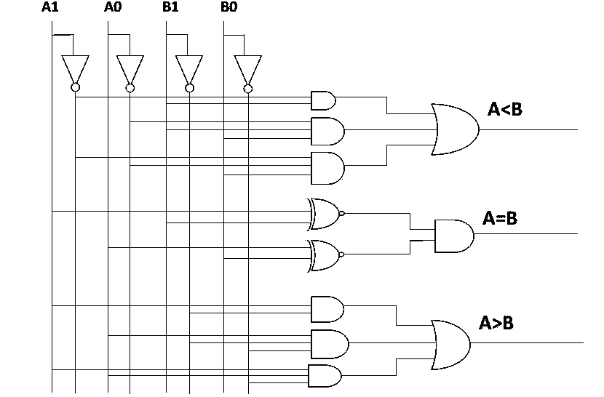  
Figure-3: Logic Circuit of 2-Bit Magnitude Comparator

Multisim Diagram:

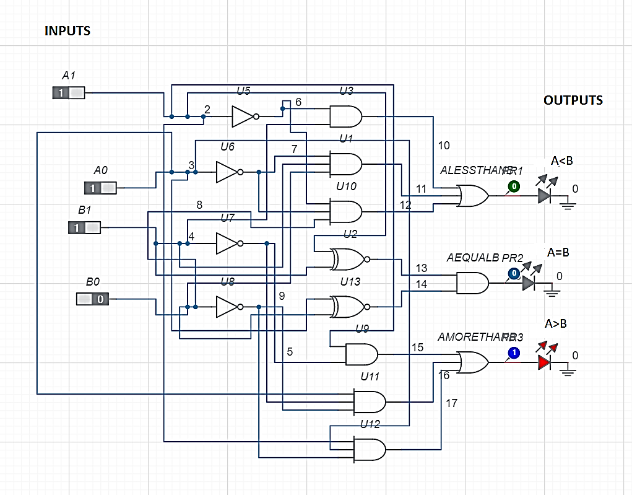

Figure-4: Multisim Circuit of 2-Bit Magnitude Comparator

**Simulation diagram:**

**Input:**

**Output:**

**Result:**

Thus the 2 bit magnitude comparator was designed and verified with the truth table using Multisim software.

**Expt No: 7b**

**Date:**

**Hardware Implementation Using NI Analog Discovery 2**

**Aim**

Hardware Implementation of the same with NI Analog Discovery 2.

**APPARATUS REQUIRED**

|  |  |  |  |  |
| --- | --- | --- | --- | --- |
| **S.No** | **Apparatus** | **Types** | **Range** | **Quantity** |
| 1 | IC | IC 7486 |  |  |
| 2 | NI Analog Discovery 2 |  |  |  |
| 3 | Wires |  |  | As Required |
| 4 | Bread board |  |  | 1 |

**CIRCUIT CONNECTION:**



**Truth Table**



**PROCEDURE:**

1. Fix the IC 7485 in the breadboard.

2. Red wire belongs to power. Take a wire connect to red wire and wire it to pin 16.

3. Black wire belongs to ground. Take a wire connect to Black wire and wire it to pin 8.

4. Short pins 4,2 of the IC and wire it to ground.

5. Interconnect pin 3 and 16.

6. Use Pin 0 - Pin 7 of AD2 as Input.

7. Connect Pin 0 - Pin 7 of AD2 to IC Pin 15,13,12,10,1,14,11,9 (A3, A2, A1, A0, B3, B2, B1, B0) respectively.

8. Use Pin 13- Pin 15 of AD2 as Output.

9. Connect Pin13- Pin15 of AD2 to IC pin 5,6,7 respectively.

10. Search the application in PC for Waveform 2015.



11. In the above window click the Supplies Instrument.



12. Use only positive supply. Change the voltage as 5.

13. Click Master Enable button to enable the Instrument.

14. In the Welcome tab, select Static IO Instrument to open.



15. Configure Digital I/O signal into a switch by selecting 0-7 Switch to Push/Pull (1/0) as seen in Figure below for DIO 0-DIO7



16. Run both Static IO and Power Supplies Instrument.

17. Verify the truth table by changing the switch position.

**Connection Diagram**

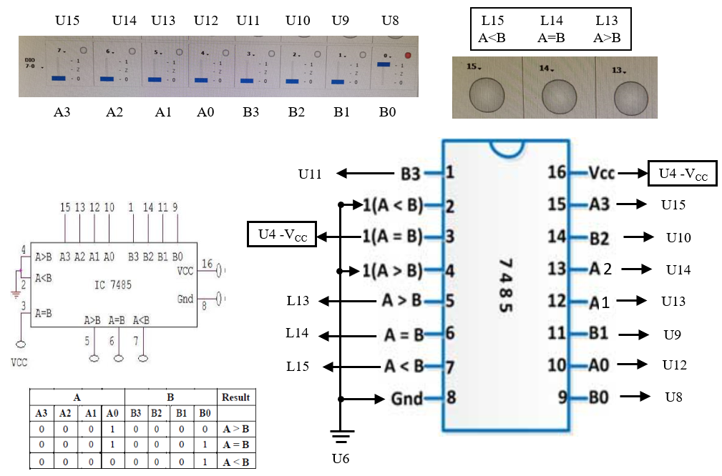

**RESULT**

Thus, design and implementation of Magnitude Comparator using Multisim and NI Analog Discovery 2 is done.